|  |
| --- |
| Close-up image showing the leaf-sides of two oversized books side-by-side on a bookshelf, with additional books in soft focus background |
| BFCAI Library   |  |  |  | | --- | --- | --- | |  | Eslam Hany Zoghla |  | |
| |  |  |  | | --- | --- | --- | |  |  |  | |

**Library application**

**Abstract:-**

**The purpose of the project is to create a library system in the college.**

This system helps the librarian in managing the library and converting it to the digital system. It provides some features, for example, adding books to the database and modifying them, or searching for a book request from the student, controlling and managing students and adding them to the database. We used visual studio code and SQLite app to make this system. The application is divided into 5 screens. The first screen is the main screen and the remaining four are sub screens. The main screen has four buttons, when you press any button, the main screen disappears and any of the sub screens appears according to the button, and can back to the main screen.

**In the visual studio code ,we used 7 files:-**

**1.App.py:-**

Set size function has two arguments to enter the dimensions of the screen when you call them.

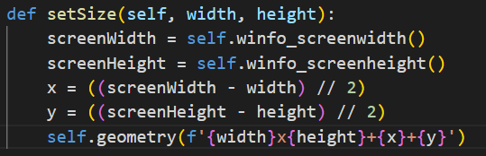

Go to screen function has one arguments to enter the name screen to open in the screen

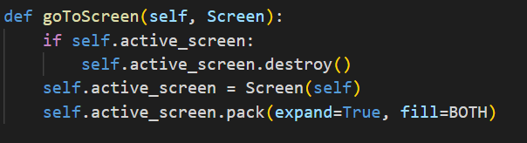

**2.Main.py :-**

**Screen:-  
  
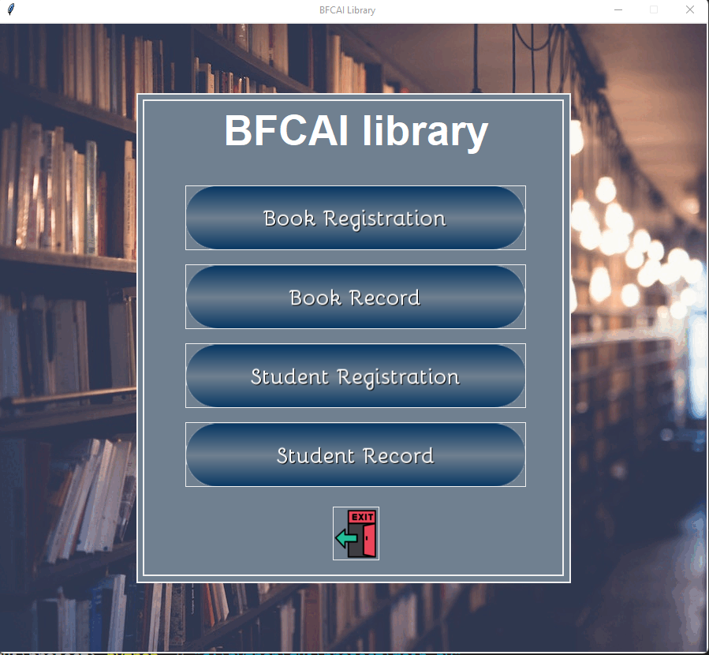**

**description:-**

This is the first screen that appears when you click to run the program. In this screen we show the five button and one text in top. The text called BFCAI library, and the button called book registration, book record, student registration, student record and exit to move from one screen to another easily.

**code: -**

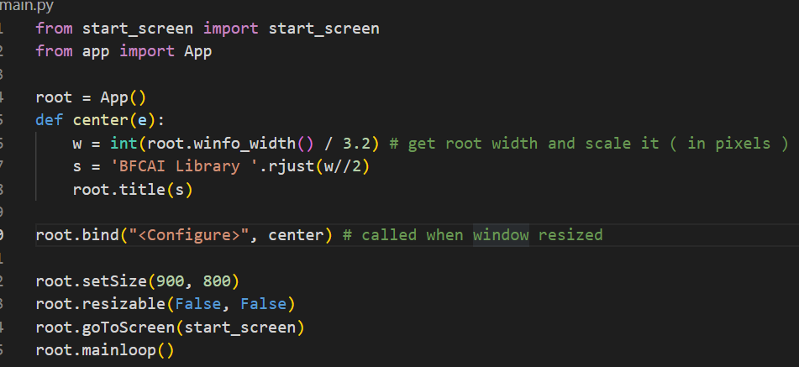

**3.bookregistration.py: -**

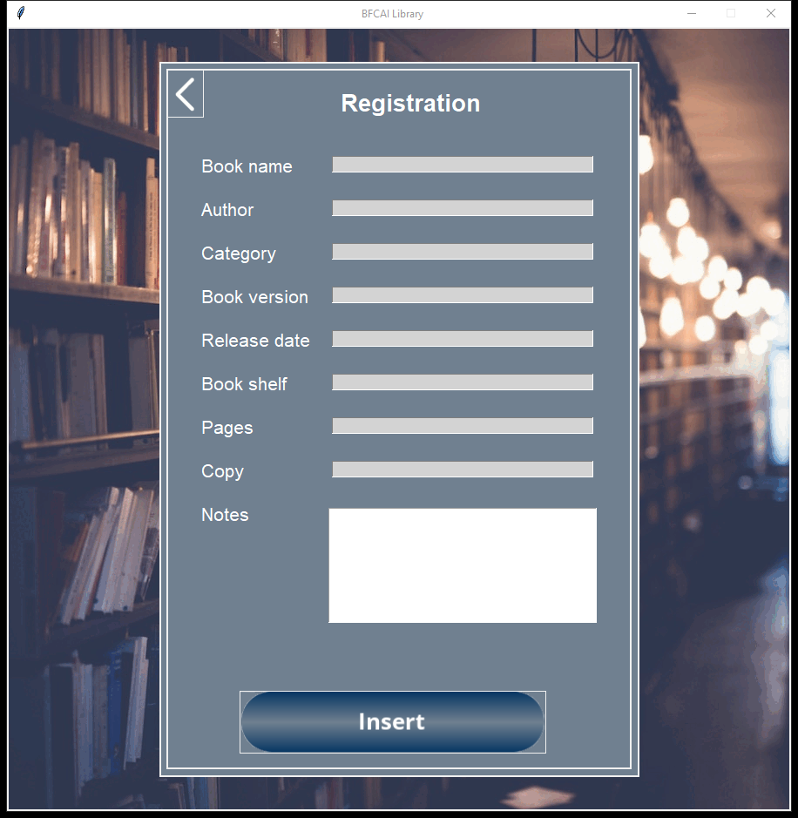**Screen: -**

**description:-**

It's a frame used to collect and register all required data of a book in each and add it to library database.

Its content 2 button

1. Back button to return to start screen
2. Insert button to add data to database after gather all data.

**Code:-**

**1.**

def __init__(self, app):

        super().__init__()

        self.app = app

        app.setSize(900, 900)

        self.backImage = PhotoImage(file="images\\back7.gif")

        self.backButton = PhotoImage(file="images\\backbutton1.png")

        self.insertButton = PhotoImage(file="images\\insert.png")

        self.initGUI()

this contractor inherited super class (App), its content path of background image and buttons .

2.

def clear_enteries(self):

        self.enterBookname.delete(0, END)

        self.enterAuthor.delete(0, END)

        self.enterCategory.delete(0, END)

        self.enterBookVersion.delete(0, END)

        self.enterReleaseBook.delete(0, END)

        self.enterPages.delete(0, END)

        self.enterCopies.delete(0, END)

        self.enterBookShelf.delete(0, END)

        self.notes.delete("1.0", "end")

this function used to clear all entries in this frame.

3.

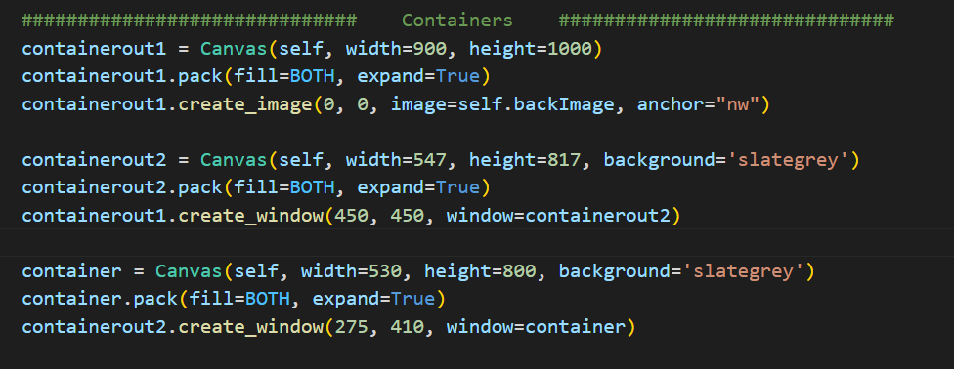  
these containers are content background image and all components.

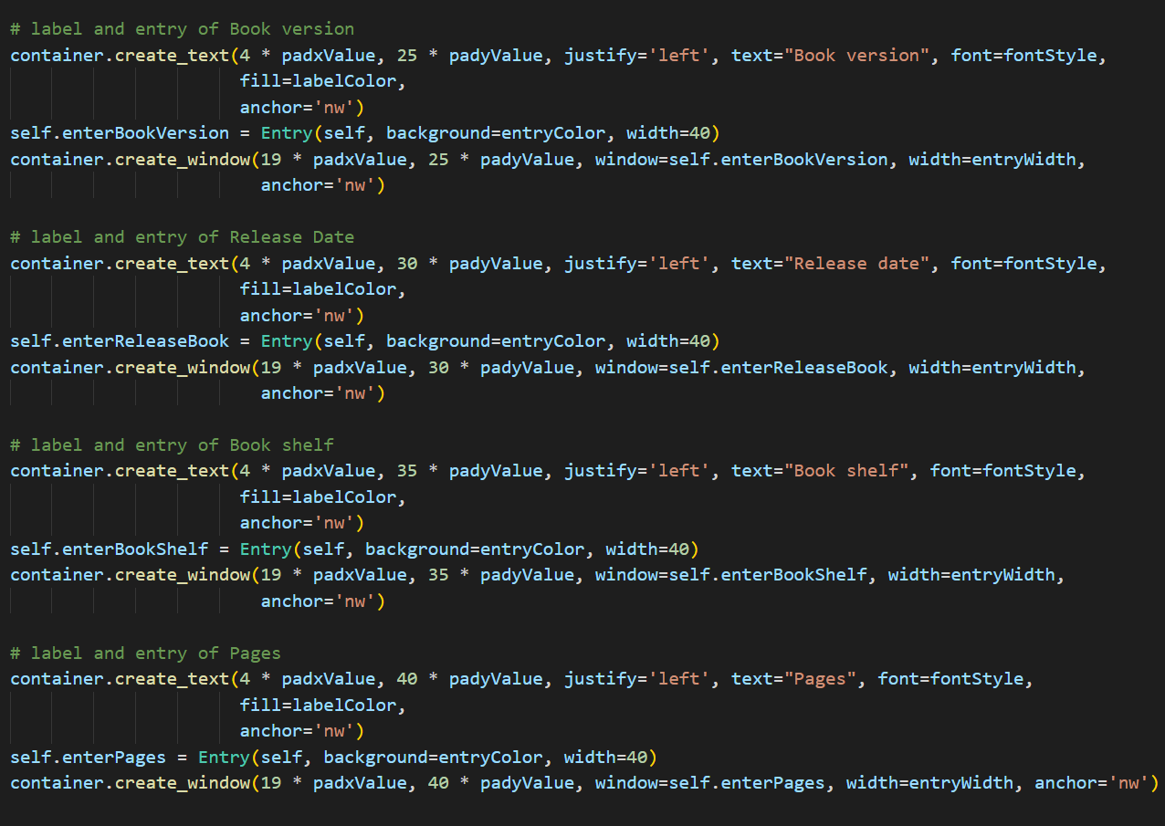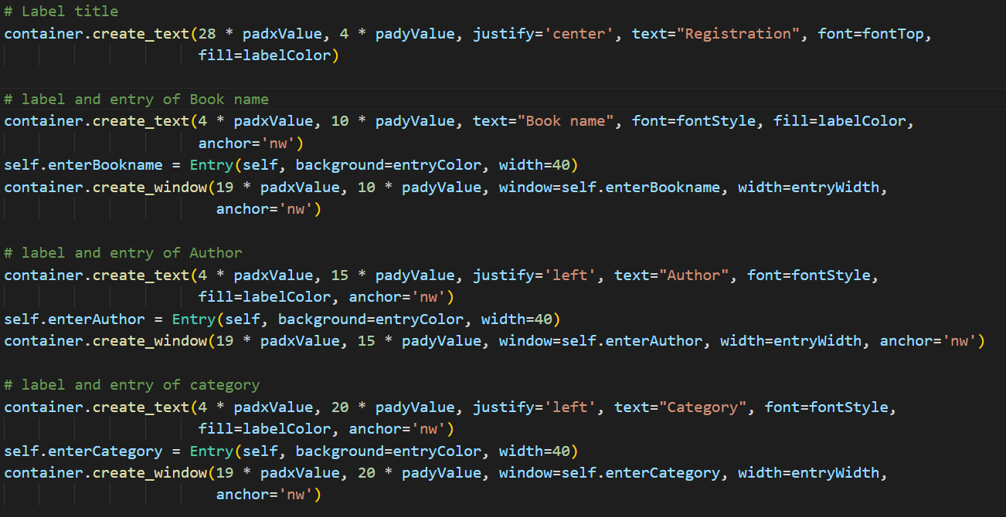4.

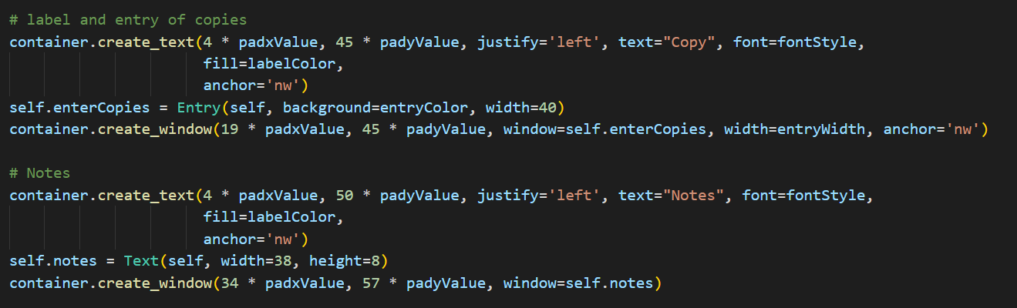

These are codes of entries and his fixed position on screen and specific font, width, color and so on.

5. onClick_insert(): -

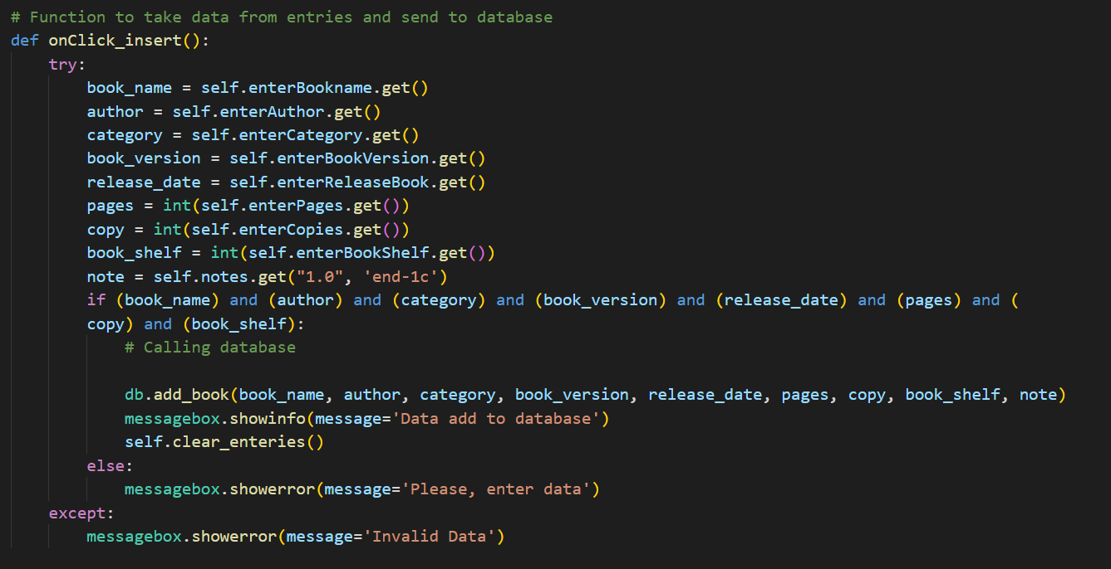

This function used to collect data from entries and send it to be added to database by calling function add_book(…) we will see it later. If user doesn’t enter any field, it will print message “Please, enter data”.

6.

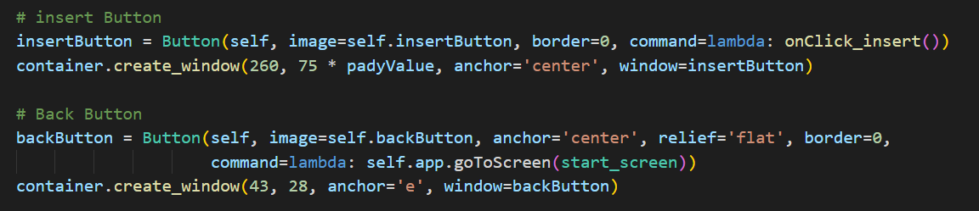These buttons that show on screen, its coded with fixed position and specific font, width and color.

Each button has commend for example,

1. Insert button calling function onClick_insert()

shown in previous page

1. Back button used to return to previous screen(main screen).

**4.bookrecord.py: -**

**Screen:-** 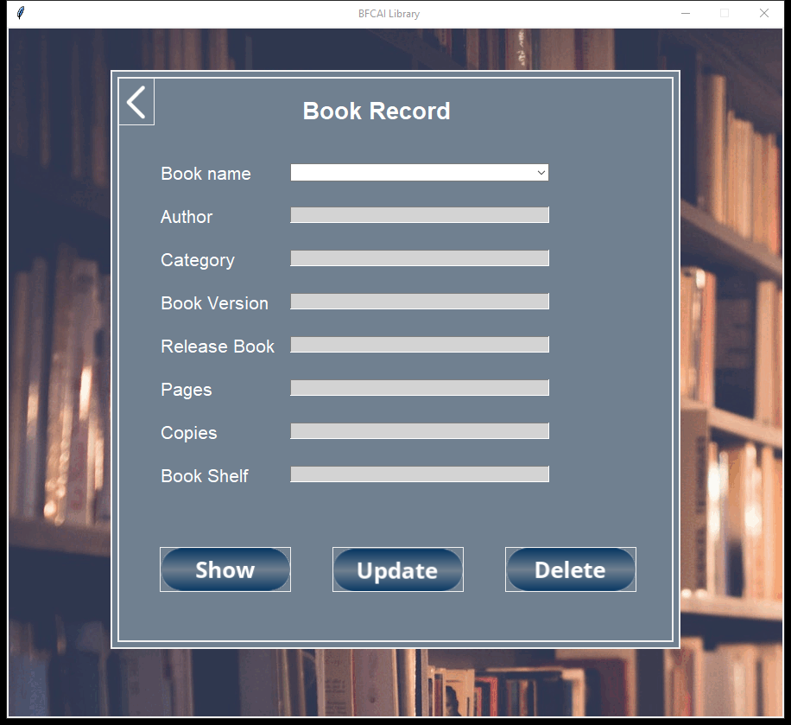  
 **description:-**It's a frame which has all the data of books in the library and where we can show all the data of the library , update the data of a book in each , delete a book from the library and search about book using its name only.

**Codes:-**1.  
this contractor inherited super class (App), its content path of background image and buttons .

2. Show_data():-

this function used to show data in table tree.

3.  
these containers are content background image and all components.

4.

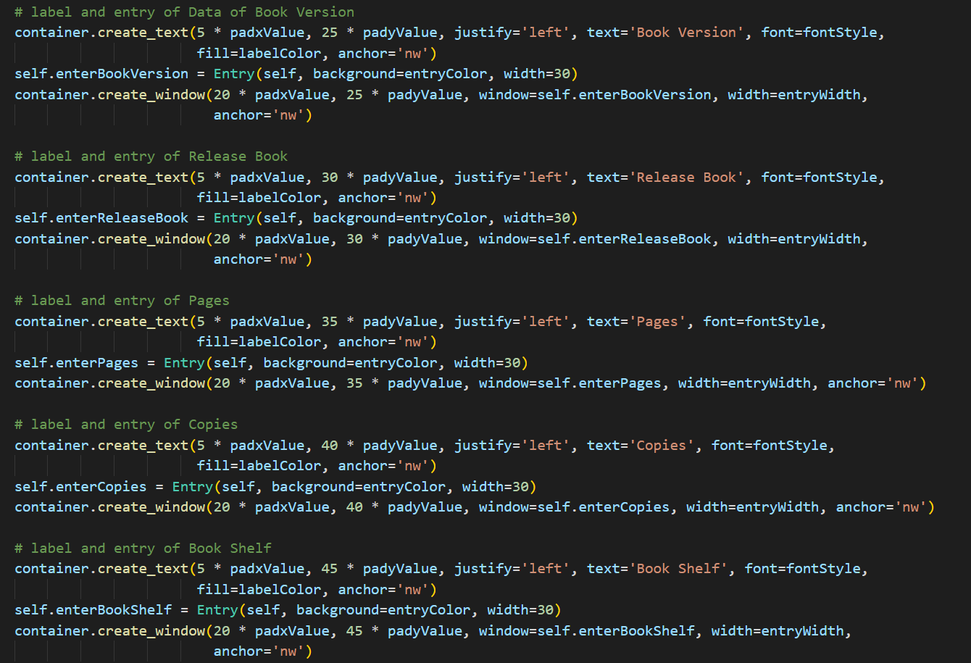These are codes of entries and his fixed position on screen and specific font, width, color and so on.

5.table_row_click()  
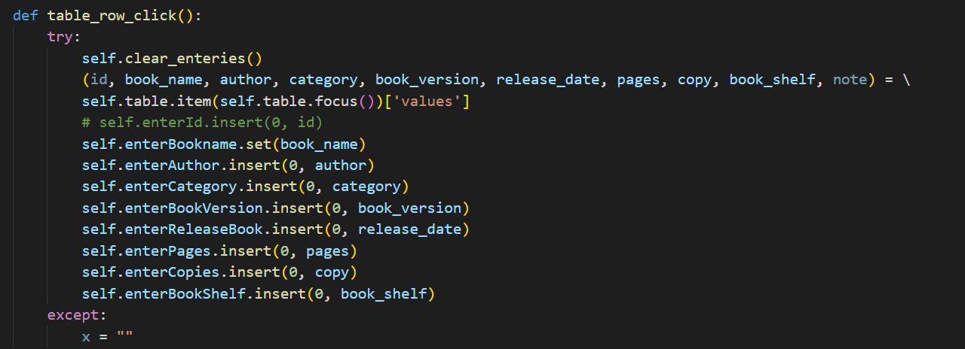used to collect selected table data and passing it to entries.

6.ClickOnCombo()

used to get selected book from combo box and get all data to its name and passing it to entries.

6. ClickUpdate()

This function used to update data of specific book and must entered all date otherwise, you will show message “Please enter date”.

7.ClickDelete()

This function used to delete specific book from database, you can’t delete any data without select their name.

8.

def clear_enteries(self):

        self.enterBookname.delete(0, END)

        self.enterAuthor.delete(0, END)

        self.enterCategory.delete(0, END)

        self.enterBookVersion.delete(0, END)

        self.enterReleaseBook.delete(0, END)

        self.enterPages.delete(0, END)

        self.enterCopies.delete(0, END)

        self.enterBookShelf.delete(0, END)

        self.notes.delete("1.0", "end")

this function used to clear all entries in this frame.

9.  
show all the data of book in a shape of table and by selecting in any row of them you can fill the entries by selected data

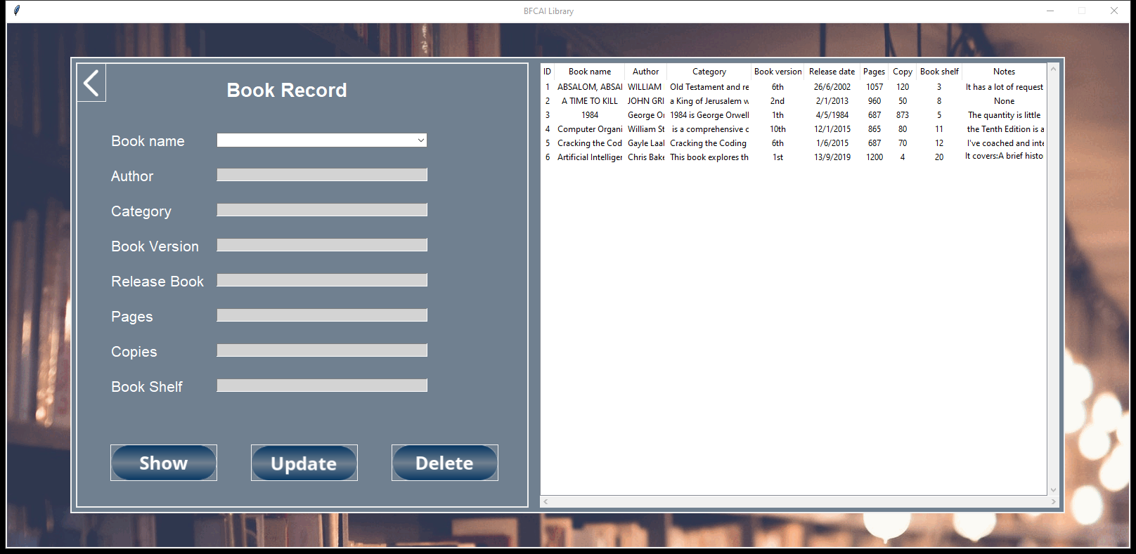-> Note the return date if it hasn't come yet it will appear black as normal if the return date has already come or it passed the color becomes red ("warning method").

This table will shown when you clicked this button

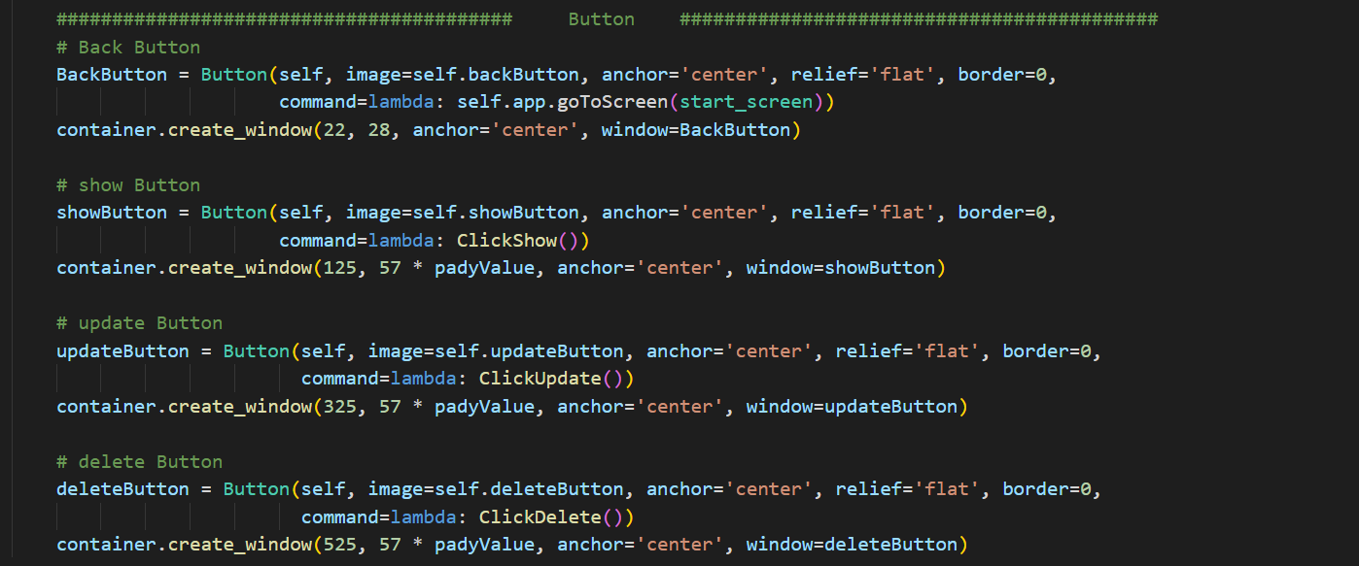10.  
These buttons that shown on screen, its coded with fixed position and specific font, width and color.

Each button has command for example,

1. Back button used to return to previous screen(main screen).
2. Show button used to call function Show button.
3. Update button used to update specific data entered.
4. Delete button used to delete select book within combo box from database by deleting all record to this book.